# Women Safety App: Guardian

At Microsoft, our focus is on addressing societal challenges and in contributing to making the nation a safer place for all its citizens. In channeling our interest, enthusiasm and a passion for technology that makes a difference to people and communities, we decided to act by working to prevent crimes against women by developing a software that will enable people to summon help within minutes and create effective deterrents against such crimes.

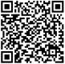The result of our thinking led us to develop a Window Phone 8 application, called **Guardian**. With a real-time tracking and intelligent SOS alert function, a call for help and recording the evidence of attack, this application helps to pose an effective deterrent to the perpetrators of these crimes, and to help fight against these injustices. This app is **Live in store** and can be downloaded from [here](http://www.windowsphone.com/en-in/store/app/guardian/178406e1-0363-43ee-8be0-e2945fa18d6b) or by scanning the QR Code.

The app helps women in distress by **alerting their friends,** **families as a standalone app,** as well as it is **available as an integrated solution for Police** or security agencies who can **monitor distress SOS calls and provide help through a portal**.

# Guardian

**Guardian** is a Windows Phone 8 based application*, aimed to provide greatest coverage and mobility. It has been designed as a cloud based service using Microsoft Windows Azure cloud services. It also uses Windows Phone 8 and Bing Maps for location among other component technologies.

Guardian utilizes the **combined power of your buddies and security agencies** when you seek help. This ensures in getting help faster. It also provides directions to **local help such as police, hospitals** and other agencies. With meaningful SMS alerts, it ensures that the coverage for the app is maximum.

Because the Guardian ecosystem has a cloud based infrastructure, **even if the attacker destroys the phone or the GPRS connection gets lost, the system intelligently keeps relaying SOS alerts**, seeking assistance.

*\*The application is available for Windows Phone platform today and it can be scaled-up for other platforms (Android/iOS) very easily by writing simple clients, which would talk to the same Windows Azure backend and services seamlessly*

It consists of a Windows Azure hosted Website called Guardian Portal. To connect the Guardian App to the Guardian portal, we use a middle tier running on Windows Azure cloud which utilizes Windows Azure Mobile services, web-roles and cloud storage to host all the logic and intelligence for the platform. The portal uses Bing Map API’s extensively to show the tracking and SOS details of the users on the map.

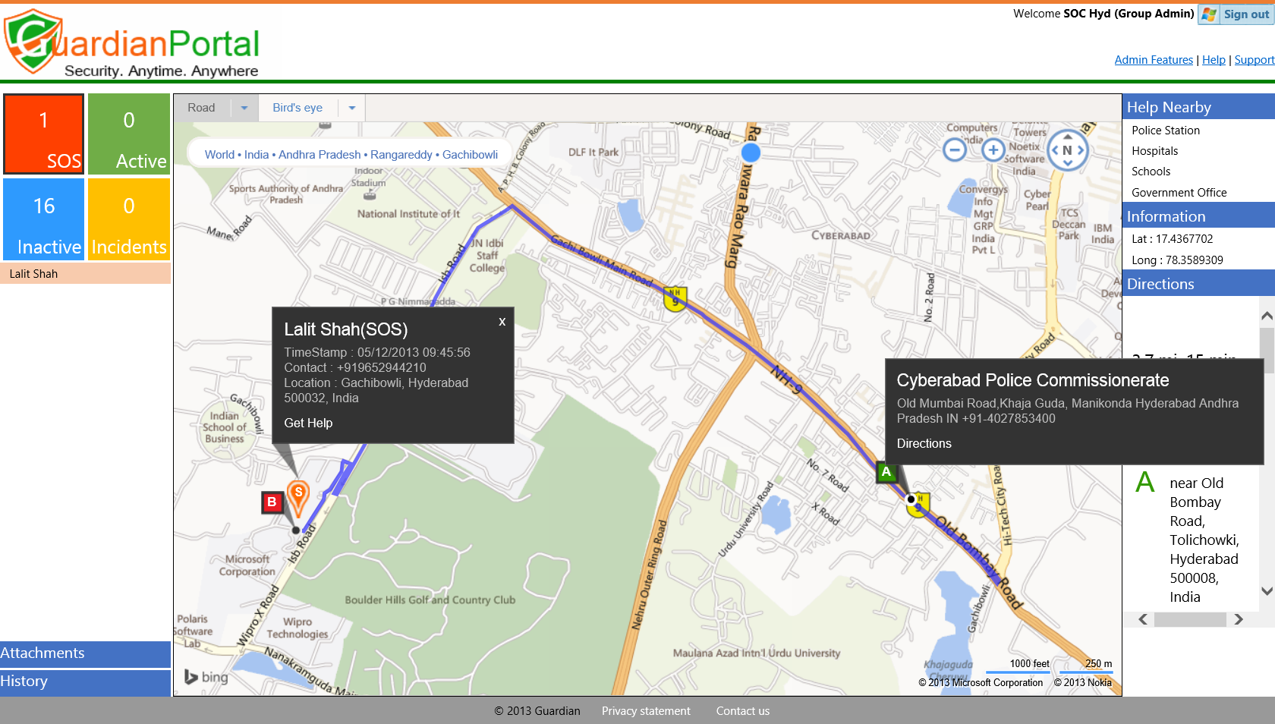

Outlined below are the key features of the app:

* **Guardian: Windows Phone 8 App**
  + Real-time tracking by buddies and security agencies
  + Continuous SOS, even if the phone is destroyed
  + Social network integration with privacy
  + Record evidences on cloud
  + Get local help on the phone
* **Guardian Portal: Accompanying Web Portal**
  + Runs on Windows Azure
  + GPS coordinates based trail locator
  + Information of nearby resources for help

# Detailed Features:

* **Easy set-up** through phone
* **Acknowledgement** from buddies for help
* Real-time monitoring by Security agencies
* **Self-Tracking** and showing route
* **One Click SOS Triggering**
* Ability to send **recurring SOS signals**
* Initiating **immediate call** with a buddy
* **Facebook** posting with location (to a private group)
* Email with your **location** to buddies
* SMS with location and **tracking trail**
* **Send pictures** to buddies & security agencies
* SOS continues when the phone is **destroyed**
* No GPRS (Internet): Start SOS through SMS
* Safety message after turning Off SOS
* **One click** Call/SMS to buddies while in SOS
* **Emergency Calls** (Police, Hospitals, Fire)
* Route to **Local Help**
* **Track people** who have added you as Buddies
* Being tracked by your buddies in real-time
* Organizations can track their employees
* Saving your **tracking trail and SOS photos in cloud** for evidence
* **Incident reporting** like tease, ragging etc. along with evidence in cloud
* Security agencies can send Police/Medical Help to you when in SOS
* Security agencies can assign **Rescue Marshals**
* **Multiple profiles** for different cities
* **One click** settings restoration on a new device

# Guardian: High level Architecture

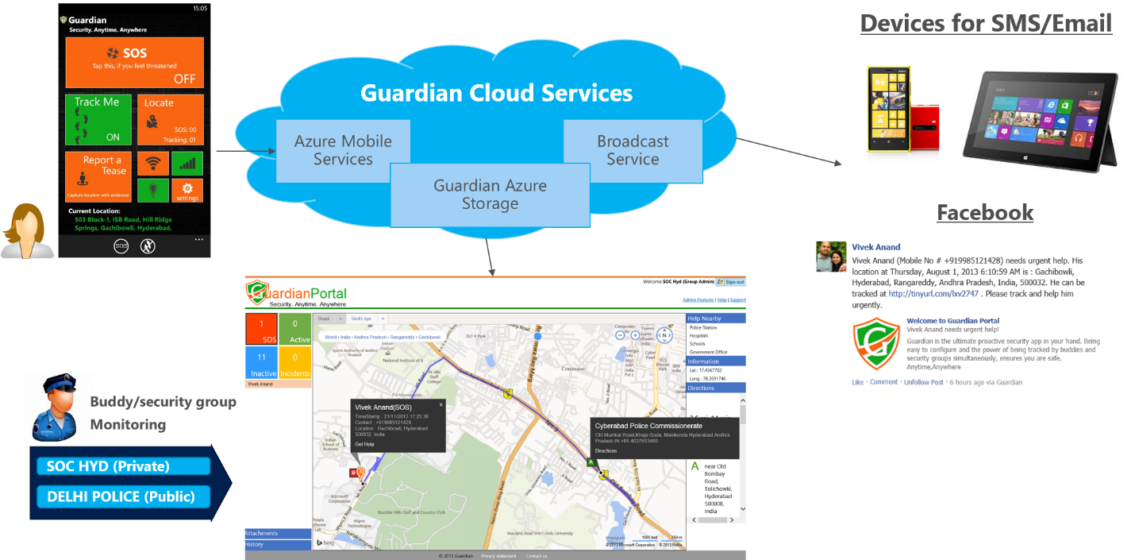

# Case studies

1. Guardian app is being **used as a safety app for 5000+ Microsoft employees** PAN India. Microsoft Security operations center monitors employees 24X7 through the Guardian portal and reaches out to them if any help is sought through Guardian App.
2. Guardian team is **partnering with UNWomen**, New Delhi on their Safe cities Research and Initiative.
3. The Guardian app was launched on Windows Phone store in India on 22nd Nov and has got **7000+ downloads** till date.
4. Below is a guardian feature which shows the even distribution and app usage for Guardian application, reported in last 10 days.

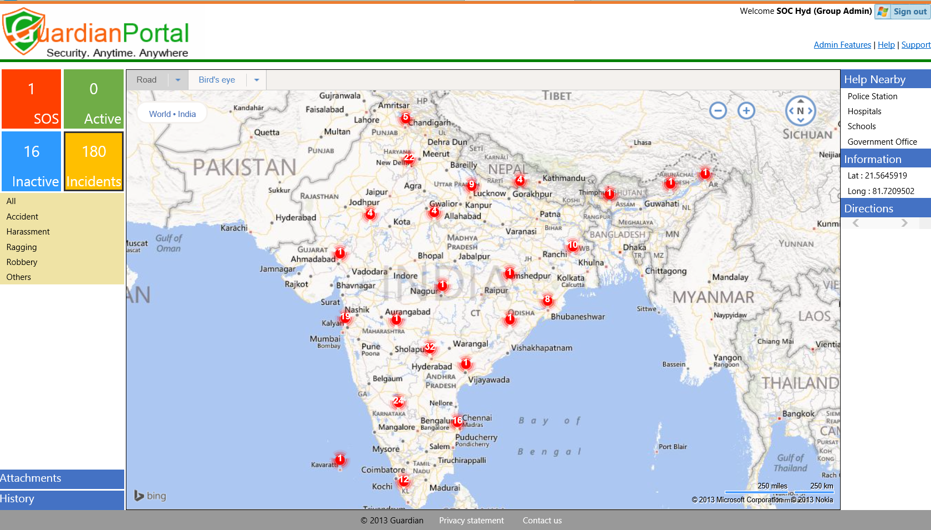

# Appendix

## Guardian Demo Video

Here is a demo video which shows the capabilities of Guardian application



## Guardian Flyer

Attached is the flyer for Guardian application

